**Bourne Arts & Community Trust (BACT)**

**Lead Architect & Building Professional Team Brief**

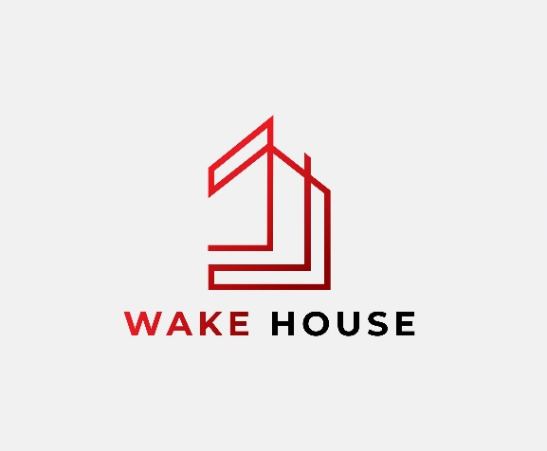 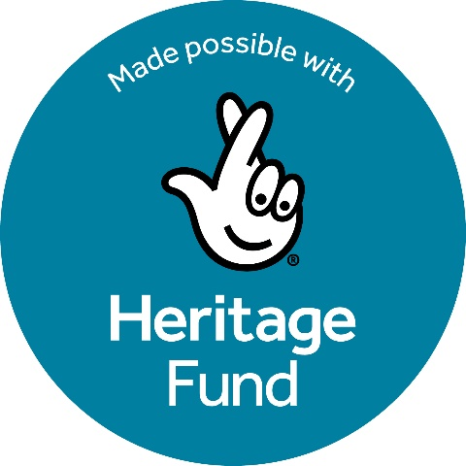

**Celebrating 200 years of Worth**

Bourne Arts and Community Trust is seeking an experienced Lead Architectto lead and manage the building aspects of the development stage of our project and support a delivery stage application to The National Lottery Heritage Fund.

BACT is a registered charity which has managed Wake House since 1999. We have eight volunteer Trustees and four part time staff. Our mission, briefly stated, is to provide facilities for socially useful organisations and activities supporting the people of the area, and to preserve Wake House which is a Grade II listed building. Wake House is an essential community resource for organisations which support disadvantaged people; in particular, those at risk of social isolation or suffering from mental and physical heath challenges.

BACT, based in Wake House in the centre of Bourne, Lincolnshire has been awarded a development grant from The National Lottery Heritage Fund for our “Celebrating 200 years of Worth” project, which has a total project budget of £202,526. We are at the beginning of the development phase of the project, planned to last 12 to 15 months.

1. **LEAD ARCHITECT & BUILDING PROFESSIONAL TEAM POSITION SUMMARY**

1.1 BACT seeks expressions of interest from suitably qualified and experienced individuals or practices (in the latter case, we would require the Lead Architect to be a named individual) to develop a building restoration plan to support a delivery stage grant application to The National Lottery Heritage Fund.

1.2 The Lead Architect will work with BACT and the wider consultant team to meet the conditions set out in the development grant notification letter from The National Lottery Heritage Fund and contribute to the delivery stage application to The National Lottery Heritage Fund.

1.3 It is essential that the Lead Architect fulfils all aspects of the project within agreed timescales and the approved resources.

**2 PROJECT BACKGROUND AND CONTEXT**

This consultancy forms part of our “Celebrating 200 years of Worth” project, to be funded by the NLHF.

The project has two parts:

**A** – **Building Improvements:**

Building repairs are approaching urgent (e.g. repair of render, damp, wood framed and Crittall windows) and improving access into / around the building while conserving heritage features.

**B – Celebrating the heritage of Charles Worth (CFW) and his 200 Years anniversary with development of activities to engage audiences and development of interpretation.**

Development of a comprehensive activity plan for the delivery stage. Underpinned during development by research in preparation for the October 2025 200-year anniversary of CFW’s birth. Including planning inclusive events, celebrating local, national and international connections to his birthplace, coordinated with other venues (local, national and international). Improved interpretation to explain CFW’s significance.

The historic building, prominently located on Bourne’s high street, contributes greatly to the street scape and is a key building in the Bourne Conservation Area. Wake House is owned by local charity, Bourne United Charities (BUC), which has granted a long lease to BACT. The building was neglected prior to BUC’s purchase, but since then, because of the long lease, BACT has been able to restore part of the building improving the face it presents to Bourne’s main street.

Significantly, our building is also the birthplace (1825) of Charles Worth who moved to Paris as a young man and founded “Haute Couture” and “The House of Worth”, a very successful international business; this heritage story is underdeveloped, but creates considerable interest and as part of the project we wish to celebrate the 200 years anniversary of his birth with research, eye catching events and interpretation. We will use these opportunities to engage the community, using consultation and feedback to feed into the development of the activity plan for the delivery stage of our project.

Our vision is to use this legacy to attract people to the building and the area and to inspire people through the spectacular success of a determined young man from a historically isolated rural town.

The funding of the development phase from The National Lottery Heritage Fund will inform our delivery phase application.

The Lead Architect will work with the Project Manager, the Project Board (formed from BACT Trustees and the project manager) and with BACT’s staff and volunteers and other consultants/specialists who will be needed for the project to ensure the provision of all relevant costing and other information/ documents required for the delivery round application.

The Lead Architect will report to the Project Board (comprising representatives of BACT and the Project Manager) and will recruit and manage a team of building specialists to produce the outputs needed for the delivery round application. the delivery round application. The Lead Architect will also need to work closely with other consultants working on the project.

**3 DESCRIPTION AND CURRENT CONDITION - WAKE HOUSE, THE BUILDING**

Grade II listed Wake House occupies a prominent position on Bourne’s main street and contributes significantly to the historic streetscape in Bourne’s Conservation Area. It comprises a three storey Georgian house (c1800) and the next door old “Windmill” tavern, which were joined in the late 19th century, extended, and adapted over time for use as the local council offices.

It retains some original or very early features (e.g. decorative dentil cornicing facing the street, window shutters, gas light point, early staircase), though many are in need of some rescue work, and sadly many more were lost during alterations. Exploring the historic form of the building will be an objective during repair work.

The building was rescued in 2019, when BACT obtained a long lease and the building’s most critical faults were rectified, however, much work remains. A priority for the project is capital works to bring the building to a sound condition so that it can be maintained through a programme of normal maintenance work.

Briefly the work of the project includes:

* review of the existing building survey/investigations and preparation of detailed plans and specifications for specialist work, confirming they are comprehensive and accurately costed, including conservation work to address long term deterioration and unsympathetic / poor historic changes including:
  + rotting wooden windows,
  + corroded and distorted steel framed windows,
  + poorly constructed roof details allowing water ingress,
  + degraded historic lime render which has been partly patched and covered with unsuitable cement,
  + inadequate and unsuitable white plastic guttering).
* refine and cost the improvement of access to the building, based on existing specialist Access Audit recommendations and advice to accommodate the needs of infirm and disabled people e.g. to providing access from the front pavement (current problems include: four steps to the front door and difficult, narrow doors at the rear, also, long term deterioration of the rear ground surfacing causing unsafe walking conditions).
* Renewal of Listed Buildings Consent (previously obtained in 2017).
* Drafting a long-term environmental improvement plan for Wake House, so that environmental improvements are considered and planned into any future change and activity in Wake House (including this project).

**4 BUILDING OWNERSHIP AND CURRENT STATUS**

Wake House, the building, is now wholly owned by Bourne United Charities (BUC). It was purchased by BUC in 2017 from the local council, at the request of BACT.

BUC’s ownership and BACT’s tenure of the building are now secure – the building having been purchased by BUC specifically so that BACT could be provided with the secure tenure of a long lease (30years from 2017).

**5 PROFESSIONAL TEAM**

The Lead / Conservation Architect (including CDM consultant as required) will be expected to recruit team of building professionals.

All professionals will be required to demonstrate that they are qualified to undertake the work and to provide evidence of an appropriate level of experience in historic buildings conservation.

Architects are invited to propose members of their professional team, but tenders for each member of the team must be submitted individually and all appointments will be made by BACT as the client (with the support of HTL). The lead architect will be expected to act as co-ordinator for the work of the professional team and BACT will provide all information and all instruction directly through them. However, we reserve the right and expect to discuss the progress of the project with any member of the team directly.

Specialists (as required) are planned to be appointed to carry out the following specialist work to produce reports to inform the design process:

* + Quantity Survey
  + Structural Engineering
  + Ecology (including bat survey)
  + Drainage
  + Ground condition
  + Building condition
  + Building archaeology – for research and recording to inform statement of significance
  + Party Wall surveyor
  + Accessibility
  + Asbestos - if the existing report is inadequate

**6 SPECIALIST DEVELOPMENT WORK**

The Lead Architect will be responsible for the procurement of all specialist reports. If you would suggest any additional specialist input please identify this within your tender.

In order to take the project forward, BACT requires the following work to be completed:

a) A comprehensive condition survey to include structural survey where required (several previous surveys are available for review). The survey should include a photographic record, drawings and a costed repair schedule.

1. A conservation management plan, including statement of significance (to be informed by an archaeological building recording and research that will be commissioned separately). This is to be prepared in partnership with HTL in order to allow their staff to learn and develop during the project, and according to the English Heritage Conservation Principles, Policies and Guidance document, 2008.

c) Preparation of detailed drawings of the property as existing and as proposed, to be made available to the professional team and all other specialists contributing to the development work.

d) Preparation of detailed design specifications in order to feed into the production of schedule of works and bills of quantities by a separately appointed Quantity Surveyor. (This should include M&E design and consultation with a CDM consultant as required.)

e) A management and maintenance plan for the scheme which allows BACT and HTL to plan for the ongoing care of the site.

f) Consultation with the Conservation Office for listed building consent matters (building regulations and other regulatory compliance actions as applicable).

g) Preparation of tender documentation and acting on behalf of BACT to enact the tender process in line with their procurement guidelines (note: Tenders must be valid for a minimum period of 12 months).

h) Drafting a long-term environmental improvement plan for Wake House, so

that practical environmental improvements are considered and planned into

any future changes.

1. The appointed lead professional will act as an agent for BACT and ensure compliance with all relevant legislation, policy and practice. This includes all requirements of all funding partners.

If this project is successful in gaining NLHF stage 2 (Delivery) funding, BACT plans to continue with the same design team unless there is a reason why this is no longer appropriate. Please include in your tender details of how you will support the project through to RIBA stage 7.

The successful team will be required to provide learning opportunities for university students at both development and delivery stages. During work experience / placement may be offered if practical.

**7 OBJECTIVES**  
the Lead Architect must:  
i) Plan and organise activities as described above to deliver the required outputs

ii) Recruit and manage suitable experts to achieve the objectives of the project

**Outputs/Deliverables**

Specialist Reports as listed in 6 above

Outputs as listed in 7 above, principally:

Updated condition survey (including structural aspects as necessary)

A Conservation Management Plan, including statement of significance

Detailed drawings of the property as existing and as proposed

Drawings and specifications (as necessary for both the listed building Application and the building contractor tendering exercise)

Schedule of works and bills of quantities

Listed Building Approval for the planned works

A management and maintenance plan

A long-term environmental improvement plan for Wake House

**Award Criteria**

**Proposals will be evaluated based on:**

List what you expect proposals for carrying out the work to include, for example:

* Demonstrable experience of previous relevant work (with good outcomes) details of staff allocated to the project, together with experience of the contractor and staff members in carrying out similar projects. The project manager/lead contact should be identified.
* Time to be allocated to the work by each staff member.
* A methodology for the project work (adequately detailed to clear)
* a time plan showing steps to produce the outputs.
* an overall value of the work (time input and suitability of planned outputs)

**8 TIMETABLE**

|  |  |
| --- | --- |
| Tender opportunity advertised | **End Feb 25** |
| Deadline for submission of tenders | **21st March 25** |
| Interviews held | **Early April 25** |
| Appointment of professionals confirmed | **April 25** |

The project work will commence on the appointment of the successful candidate in **April 2025** and will complete **Jan 2026.**

All information from the Development Phase will be submitted with a 2nd round bid to the National Lottery Heritage Fund in May2026

A full project programme as proposed at time of tendering is attached. This is subject to change as the project progresses.

**9 FEES**

The maximum fees available for this work at Development stage are:

The Lead Architect: £ **22,120** and

Specialists (total): **£20,425 -** to be paid on delivery of satisfactory specialist reports.

At the Delivery stage (**subject to a later bid to NLHF**) a further:

The Lead Architect: £ **7,373** and

Specialists (total): **£7,125**

The above is Inclusive of travel and expenses but exclusive of VAT.

**Wake House, 41 North Street, BOURNE, Lincolnshire, PE10 9AE** [**www.wakehouse.org.uk**](http://www.wakehouse.org.uk)