**Bourne Arts & Community Trust (BACT)**

**Heritage Activities Consultant Brief**

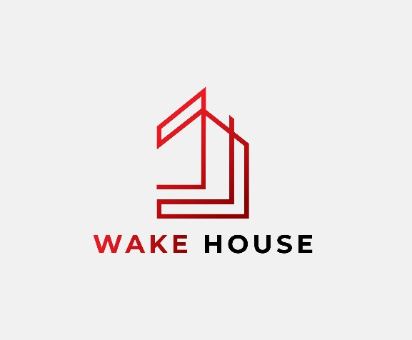 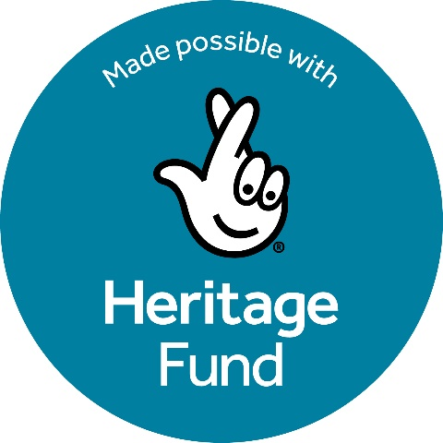

**Celebrating 200 years of Worth**

Bourne Arts and Community Trust is seeking an experienced Heritage Activities consultant to develop an activity plan and support a delivery stage application to The National Lottery Heritage Fund.

BACT is a registered charity which has managed Wake House since 1999. We have eight volunteer Trustees and four part time staff. Our mission, briefly stated, is to provide facilities for socially useful organisations and activities supporting the people of the area, and to preserve Wake House which is a Grade II listed building. Wake House is an essential community resource for organisations which support disadvantaged people; in particular, those at risk of social isolation or suffering from mental and physical heath challenges.

BACT, based in Wake House in the centre of Bourne, Lincolnshire has been awarded a development grant from The National Lottery Heritage Fund for our “Celebrating 200 years of Worth” project, which has a total project budget of £202,526. We are at the beginning of the development phase of the project, planned to last 12 to 15 months, thanks to National Lottery players.

1. **HERITAGE ACTIVITIES CONSULTANT POSITION SUMMARY**

1.1 BACT seeks expressions of interest from suitably qualified and experienced individuals or practices (in the latter case, we would require the Heritage Activities Consultant to be a named individual) to develop an activity plan to support a delivery stage grant application to The National Lottery Heritage Fund.

1.2 The Heritage Activities Consultant will work with BACT and the wider consultant team to meet the conditions set out in the development grant notification letter from The National Lottery Heritage Fund and contribute to the delivery stage application to The National Lottery Heritage Fund.

1.3 It is essential that the Heritage Activities Consultant fulfils all aspects of the project within agreed timescales and the approved resources.

**2. PROJECT BACKGROUND AND CONTEXT**

The project covers capital works and activities.

**A** – **Building improvements:**

Building repairs (e.g. repair of render, damp, wood framed and Crittall windows) and improving access into / around the building while conserving heritage features.

**B – Celebrating the heritage of Charles Worth (CFW) and his 200 Years anniversary with development of activities to engage audiences and development of interpretation.**

Development of a comprehensive activity plan for the delivery stage. Underpinned during development by research in preparation for the October 2025 200-year anniversary of CFW’s birth. Including planning inclusive events, celebrating local, national and international connections to his birthplace, coordinated with other venues (local, national and international). Improved interpretation to explain CFW’s significance.

The historic building of Wake House, prominently located on Bourne’s high street, contributes greatly to the street scape and is a key building in the Bourne Conservation Area. Wake House is owned by local charity, Bourne United Charities (BUC), which has granted a long lease to BACT. The building was neglected prior to BUC’s purchase, but since then, because of the long lease, BACT has been able to address the most critical issues and improve the face it presents to Bourne’s main street (however, much remains to be done).

Significantly, our building is also the birthplace (1825) of Charles Worth who moved to Paris as a young man and founded “Haute Couture” and “The House of Worth”, a very successful international business; this heritage story is underdeveloped, but creates considerable interest and as part of the project we wish to celebrate the 200 years anniversary of his birth with research, eye catching events and interpretation. We will use these opportunities to engage the community, using consultation and feedback to feed into the development of the activity plan for the delivery stage of our project.

Our vision is to use this legacy to attract people to the building and the area and to inspire people through the spectacular success of a determined young man from a historically isolated rural town.

The funding of the development phase from The National Lottery Heritage Fund will inform our delivery phase application.

The Activities Consultant will work with the Project Manager, the Project Board (formed from BACT Trustees and the project manager) and with BACT’s staff and volunteers and other consultants/specialists who will be needed for the project to ensure the provision of all relevant costing and other information/ documents required for the delivery round application.

**2A Wake House - Building Improvements (briefly for project context)**

Grade II listed Wake House occupies a prominent position on Bourne’s main street and contributes significantly to the historic streetscape in Bourne’s Conservation Area. It comprises a three storey Georgian house (c1800) and the next door “Old Windmill Inn”, which were joined in the late 19th century, extended, and adapted over time for use as the local council offices.

It retains some original or very early features though many are in need of some rescue work, and sadly many more were lost during alterations. Exploring the previous form(s) of the building will be an objective during repair work.

The building was rescued in 2019, when BACT obtained a long lease and the building’s most critical faults were rectified, however, much work remains. The most costly part of the project is these capital works, required to bring the building to a sound condition so that it can be maintained through a programme of routine maintenance work.

Briefly, the building aspects of the development project include:

* review of the existing building survey/investigations and preparation of detailed plans and specifications for specialist work.
* refinement and costing of the improvement of access to the building
* renewal of Listed Buildings Consent (previously obtained in 2017).
* drafting a long-term environmental improvement plan for Wake House.

**2B Celebrating Charles Worth’s 200 Years Anniversary – “The CFW Heritage Project”**

There are two heritage aspects to the project:

* the heritage of building and its historic place in Bourne and
* the heritage of Charles Worth and the House of Worth.

Both of these aspects should be developed through both:

* Much improved interpretation material and
* A significant programme of activities.

Interpretation and activities development must address the need to prepare for an eye-catching celebration of the 200years anniversary of CFW’s birth in October 2025 (during the Development phase) and a longer-term perspective continuing into the future (including through the Delivery phase of the project).

**Interpretation** **(briefly for project context):**

Existing interpretation material in Wake House is very limited and BACT would like to see this much improved and extended.

An Interpretation Consultant will be employed to plan, prepare and organise Interpretation to meet the aims of the project.

We expect the Heritage Activities Consultant and the Interpretation consultant to work closely together to develop integrated activities and interpretation.

1. **ACTIVITIES**

The **Heritage Activities Consultant** will develop a full delivery phase activity plan, including consultation with stakeholders and audiences.

In addition, several pilot activities have been planned for the development phase. Additional activities may be proposed (subject to budget availability). These are intended to support plans for the celebration of the actual Charles Worth 200 years anniversary in October 2025.

**The Heritage Activities planned so far include:**

1. **Understanding Worth - Volunteer Led Research Project**

We know we have a rich historical seam to mine around the House of Worth. This research will partly inform our interpretation plan and underpin the creation of future learning resources. The data collected will be compiled into a database with our findings made available online for all to access and learn.

1. **Summer School**

The crafting of an intricate garment worthy of the House of Worth involves a host of delicate traditional skills which are no longer as common as they once were. Working with students from both local and national educational bodies, we plan to partner with historical costume institutions and other experts.

1. **Pilot Talks Programme**

Following our extremely successful series of talks in partnership with Heritage Lincolnshire and the V&A, we want to take a deeper dive into Worth’s varied life and create a series of talks each focused on different aspects of his life. We hope to deliver these talks in partnership with institutions that have connections to Worth.

Topics could include:

Pattern Making – The early years of Charles Frederick Worth

Cutting the Pattern – Worth in Paris and the House of Worth

Fabrics From Afar – Overseas supplies connections (including ethical aspects)

Customers from Afar – Worth’s long reach in attracting customers

1. **Bourne Wide Celebration Event**

We plan a pilot Bourne wide event to recognise the role Bourne had in the life of the instigator of haute couture, the town’s heritage and to celebrate the fashion world of the 19th century. This pilot event will combine an open day(s) at Wake House with taster workshops and demonstrations run throughout the day(s) on aspects of haute couture creation. This event will run across Bourne in collaboration with local heritage attractions like Bourne Town Hall and Baldock’s Mill.

**4 OBJECTIVES**  
Work with the project board, staff and volunteers to understand and appraise current audiences and levels of engagement, known target audiences and potential audiences we are not currently engaging.

Undertake community and audience consultation to test target audiences and analyse barriers to access.

Work with volunteers to organise public consultation events to coincide with celebrating the 200-year anniversary of Charles Worth in October 2025 , ensuring activities develop the audience of Wake House and gather feedback for the future. Produce a report and analysis on completed pilot activities and CFW200 celebrations including photographic / video record of activities.

Work with the project board to develop their established framework for volunteering so that a wider group of volunteers can contribute to the project in a way which is also rewarding and beneficial for themselves.

Work closely with the Interpretation Consultant to ensure and that the Interpretation Design and Activity Plans are aligned, that plans for new interpretation are informed by an understanding of existing and potential audiences, and that displays can be used as an ongoing community resource.

Liaise with the Evaluation Consultant to determine how audience engagement outcomes will be measured and evaluated.

Present findings and proposals in an Activity Plan which complies with The National Lottery Heritage Fund guidelines and includes:

* A clear analysis of current and potential audiences including results of research and consultation.
* An agreed set of objectives for target audiences we seek to engage as part of the project.
* A deliverable costed action plan setting out how we will achieve these aims and detailing:
* Where, when and how activities will be delivered in the project’s Delivery Phase.
* How the Activity Plan contributes to the project meeting the Heritage Fund Investment Principles.
* A long-term plan for sustaining the benefits of the Activity Plan past the end of the funded project.

Submit reports in line with project timeline, meeting deadline for the Development Phase Review and the deadline for submission of the delivery stage application.

**5 AWARD CRITERIA**

Proposals will be evaluated based on:

* Demonstrable experience of previous relevant work (with good outcomes), including creating Activity Plans for successful bids to The National Lottery Heritage Fund.
* Details of staff to be allocated to the project, together with experience of the contractor and staff members in carrying out similar projects. The manager/lead contact should be identified.
* Time to be allocated to the work by each staff member.
* A methodology for the project work (adequately detailed to be clear).
* A time plan showing steps to produce the outputs.
* An overall value of the work (time input and suitability of planned outputs)

**6 TIMESCALES**

This work will commence on the appointment of the successful candidate in **April 2025**

and will complete in **Jan 2026**.

All information will be submitted with a delivery round application to the National Lottery Heritage Fund in May 26.

A full project programme as proposed at time of tendering is attached. This is subject to change as the project progresses.

**TIMETABLE FOR THE APPOINTMENT**

|  |  |
| --- | --- |
| Tender opportunity advertised | End Feb 25 |
| Deadline for submission of tenders | 28th March 25 |
| Interviews held | Mid-April 25 |
| Appointment of professionals confirmed | End April 25 |

**7 FEE**

The maximum fee available for this work at development stage is £14,000 inclusive of travel and expenses but exclusive of VAT.

**8 HOW TO APPLY**

8.1. To express an interest in this position please email CFWorth200years@outlook.com an up-to-date CV, brief statement of your interest in the project, relevant experience including two examples of recently completed relevant contracts, a detailed methodology, costings including day rate and your availability.

8.2 In considering applications, BACT will be looking for:

(a) Direct relevant experience including examples of relevant/similar projects delivered within the last few years

(b) Project methodology proposed

(e) Proposed approach to team working and communication including with trustees, project board, staff and volunteers

(f) Previous experience of developing Activity plans as part of delivery stage applications to The National Lottery Heritage Fund

(g) Name and contact details of two recent clients from similar projects/services undertaken who can be contacted for a reference and assessment of your performance

(h) The fee (daily rate) you would want to receive for this work inclusive of expenses and travel – please state whether VAT is chargeable.

8.3 For an informal discussion about our project and requirements, you are welcome to contact us initially via email to [CFWorth200years@outlook.com](mailto:CFWorth200years@outlook.com).

More information about Wake House and BACT can be found at: <https://www.wakehouse.org.uk/>

**Wake House, 41 North Street, BOURNE, Lincolnshire, PE10 9AE** [**www.wakehouse.org.uk**](http://www.wakehouse.org.uk)